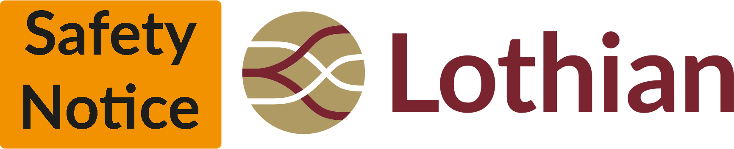
Hazard Warning
Location - <Enter street name and area>
Services Affected - <Enter Route Numbers>
Date Issued - <Enter Date>

Please be aware of <Enter Obstruction> currently affecting buses at <Enter street name and specific location eg Princes Street @ Jenners >. This issue has already caused damage to our vehicles and we are advising drivers to use caution when passing in order to prevent further damage.

The photo below shows the exact location of the issue

<Insert photo of problem area>

Your assistance is appreciated.

