Use of a Banks-person – Reversing with Assistance
Lothian have ensured that every effort has been made to reduce the need for the reversing of large vehicles, however there will always be a need to reverse from dead end pit areas and some other work areas such as the chassis wash, defective vehicles, during parking and occasionally on-street. It is Lothian Policy that a banksperson must be used during all reversing manoeuvres involving any large vehicles on our premises without exception.
When being utilised, a banksperson has full authority over all pedestrian and vehicle movements at the reversing location. Pedestrians and other vehicle drivers must follow the banksperson’s instructions.
To help ensure the safety of pedestrians when reversing the following procedures should be adhered to.
Drivers of vehicles must remember it is their responsibility to ensure the safety of their vehicle and others affected by their actions.
The Driver must:
- Switch on the vehicles four-way hazard lights
- Check both mirrors for pedestrians and hazards
- Wait for the signal/command from the banksperson
- On receipt of the start to manoeuvre command look over your right shoulder to check the offside blind spot
- Commence reversing, only if confident it is safe to do so, and the banksperson indicates it is clear to proceed.
- Keep the banksperson in your field of vision, if they lose sight of the banksperson, STOP until safe to recommence the reversing manoeuvre
- STOP the vehicle if any pedestrian, vehicle or other hazard appears, until safe to recommence the reversing manoeuvre,
- Observe light batons if utilized at the location, Green indicates proceed and RED indicates STOP IMMEDIATELY!
- Report any incident or near miss to your manager/supervisor in writing immediately

The Banksperson must:
- Ensure the driver of the vehicle is informed of the meaning of the hand signals you will use
- Ensure you NEVER STAND OR PLACE ANY BODY PART DIRECTLY BEHIND the vehicle and ALWAYS remain a safe distance away from moving vehicles
- Inform the driver to STOP immediately if you indicate RED (when using light batons) or if you go out of view during the manoeuvre
- Wear Hi Viz overalls, vest or jacket
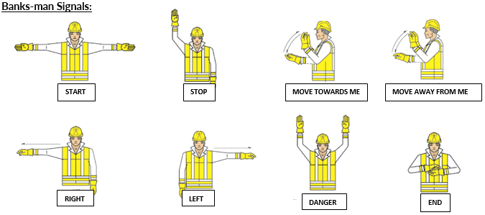
24/01/2025

This section should be retained by the staff member signing the overleaf section

I have received instruction on the locations within my workplace where reversing requires the assistance of a banksperson and how to act safely as a banksperson.

I will ensure that when I assist a reversing vehicle:
- The driver of the vehicle is informed of the meaning of the hand signals I use
- I will NEVER STAND or place any body part directly behind the vehicle and ensure I always remain a safe distance away from moving vehicles
- The driver is instructed to STOP IMMEDIATELY if I go out of view during the manoeuvre or show a RED light when batons are used
- I will wear Hi-Vis overalls, vest or jacket
- I will report any incident or near miss to my manager/supervisor immediately

I am aware that failure to use a banksperson, when required, will likely lead to disciplinary action. It is considered a serious Health & Safety breach and may constitute gross misconduct which could lead to dismissal.

Employee to complete in block capitals

NAME: ............................................................................ NUMBER: ................................................

DEPOT: ................................................................................................................

JOB TITLE: .............................................................................................................

SIGN: ..................................................................... DATE: ...............................................................

Copy to File

